

AGRICULTURAL PRODUCE MANAGEMENT SYSTEM

PROJECT PROPOSAL

PRESENTED BY :

NAME : ODHIAMBO JOHN OTIENO

REGISTRATION NUMBER : SCS3/147357/2023

Executive Summary

This is a produce tracking system designed to help farmers monitor and manage their produce from harvest to sale. The application aims to streamline produce management, providing real-time updates on inventory and sales, and offering valuable insights to improve efficiency and profitability. The scope includes 3 primary modules Produce, Sales & Reports.

This is an online platform. It allows farmers to manage update and monitor their agricultural business by accessing various services, and perform administrative tasks. Some functionalities provided by the system include produce management , sales tracking and the generation of various reports to allow farmers to keenly analyze and modernize their businesses in an efficient, professional and in a comprehensive manner no matter the scale of their operations. The system is designed to be accessed through a web-based platform that ensures secure access and centralized data storage. The platform is organized into modules which are accessed individually based on the users’ needs to provide ease of access.

Contents

CHAPTER 1 – INTRODUCTION 4

Background 4

Problem Statement 4

Objectives 4

Scope 5

Assumptions 5

CHAPTER 2 – LITERATURE OVERVIEW 6

Similar Implementations 6

AgroSense 6

Tend 7

CHAPTER 3 – METHODOLOGY 9

Waterfall methodology 9

Why? 9

Timelines 10

CHAPTER 4 - SYSTEM OVERVIEW 11

FLOW DIAGRAM 11

# CHAPTER 1 – INTRODUCTION

## Background

Managing produce efficiently is a significant challenge for farmers, leading to potential losses and reduced profitability. The system addresses this need by providing a tracking system that helps farmers monitor production, inventory, and sales.

## Problem Statement

There are numerous instances of produce tracking systems, however, most of them are expensive to small scale farmers and complex to use hence small-scale farmers currently lack a simple and effective way to monitor and manage their produce from harvest to sale. This project aims to fill that gap by offering a user-friendly produce tracking system.

## Objectives

* Develop a web application with produce tracking capabilities.
* Ensure secure access to user accounts.
* Ensure farmers can access reports on their agricultural activity.
* Ensure farmers can monitor their sales activity.
* -Ensure ease of access by implementing training tutorials.

## Scope

This will include three primary modules: Sales, Produce, and Reports, as well as additional modules Settings and Notifications on a web-based platform.

Resources

* Front end ( HTML , CSS & Java script ).
* Framework – React.
* Backend ( Database – MySQL , Server side -Node Js).
* IDE ( Vs Code).

## Assumptions

* Users have internet connectivity.
* Users have a device to access the web.

# CHAPTER 2 – LITERATURE OVERVIEW

## Similar Implementations

Here’s a breakdown of two similar systems, AgroSense and Tend, highlighting their strengths, weaknesses, and potential gaps:

## AgroSense

Strengths:

* Precision Monitoring: AgroSense excels in precision agriculture with features like soil moisture sensors, meteorological stations, and pest monitoring tools.
* Automation: It automates irrigation and nutrient management based on real-time data, optimizing resource use.
* User-Friendly Interface: The system provides a mobile-friendly interface with interactive graphs and real-time alerts.
* Customizability: It allows integration with other systems like irrigation controllers and offers tailored solutions for different crop types.

Weaknesses:

* Complexity: The system might be overwhelming for small-scale farmers due to its advanced features and setup requirements.
* Cost: High-tech sensors and automation tools could make it expensive for smaller operations.

Gaps:

- Limited Accessibility: It may not cater well to regions with limited internet connectivity or resources.

- Scalability: While great for large-scale farms, it might lack tailored solutions for very small-scale or subsistence farming.

## Tend

Strengths:

- All-in-One Solution: Tend integrates crop planning, task management, sales, accounting, and inventory in one platform.

- Traceability: It offers complete traceability from seed to sale, ensuring compliance with certifications.

- Customizable Crop Library: Users can create personalized templates for crop management, saving time and improving efficiency.

- Mobile-Friendly: The platform supports offline mode, allowing farmers to manage tasks even without internet.

Weaknesses:

- Learning Curve: The comprehensive features might require time and effort to master.

- Focus on Commercial Farms: It seems more tailored to commercial operations, potentially overlooking the needs of smaller or less tech-savvy farmers.

Gaps:

- Limited Regional Adaptation: It may not fully address the unique challenges of farming in diverse climates or regions.

- Dependency on Technology: Heavy reliance on digital tools could be a barrier in areas with limited tech infrastructure.

CONCLUSION

Both systems have their unique strengths and challenges. However, it is clear that they lack an appropriate interface that would easily be used by small scale farmers because of the complexities in navigation as well as the cost. Due to this , there is a need to efficiently facilitate the needs of small-scale farmers.

# CHAPTER 3 – METHODOLOGY

## Waterfall methodology

The **Waterfall methodology** is a traditional project management approach that emphasizes a linear and sequential process for completing projects.

## Why?

1. Sequential phases – Beginning of the next phase depends on completion of the previous.
2. Structured process – Deliverables and Milestones are clearly defined.
3. Detailed documentation – Aid in future enhancements and maintenance.

To ensure all requirements are met and the system is developed reliably.

## Timelines

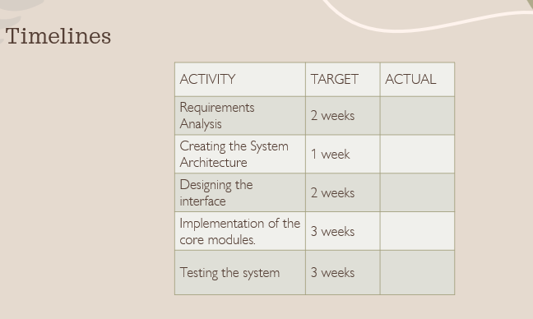

# CHAPTER 4 - SYSTEM OVERVIEW

## FLOW DIAGRAM

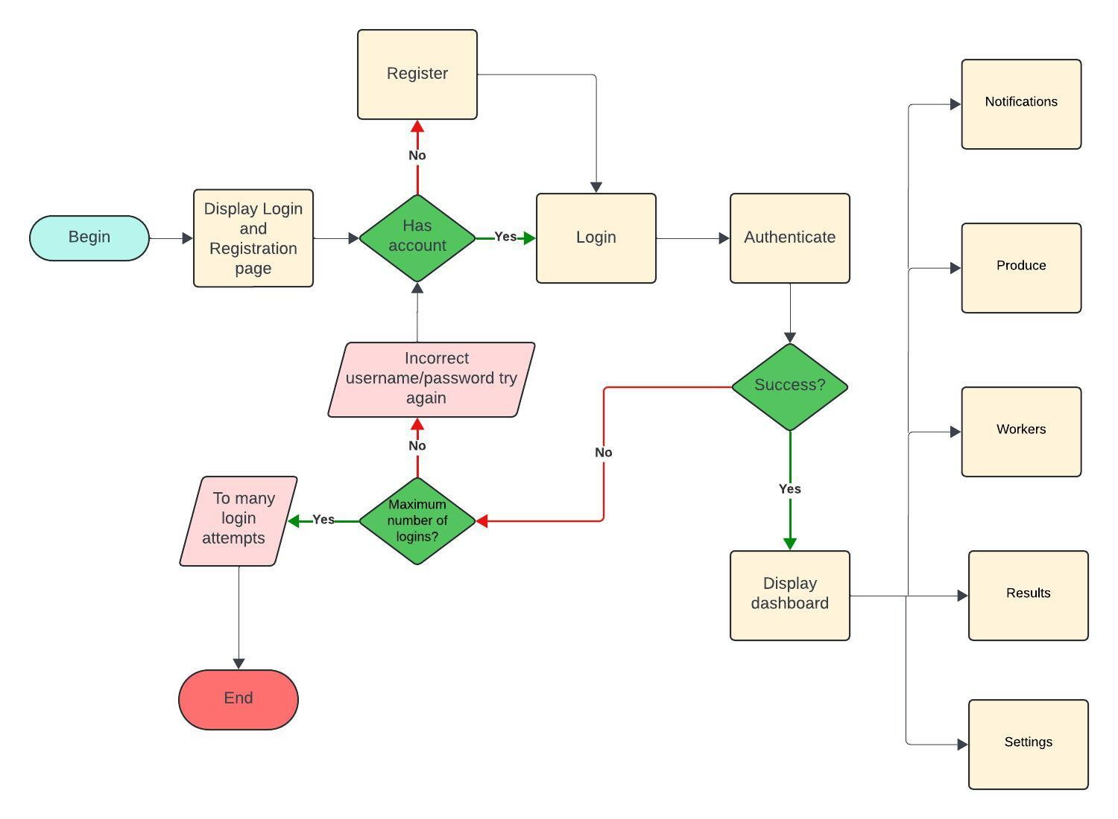

1. Settings

Submodules

1. Account management
2. Notifications
3. Security
4. Help
5. Account management

* Name
* Email
* Phone / telephone
* Country
* County
* Delete account

1. Security

* Change Password
* Enable 2FA

1. Help

* About us – Display about page
* Contact Support – Display email and telephone number
* Training tutorials – Display tutorial videos to common tasks.

1. Notifications Module

Modes of notification – email, SMS

Notify me when:

* + A sale is made
  + Harvesting season reminder
  + Low Inventory
  + Crops near spoil
  + Scheduled sale date
  + Reminders to make payments

1. Produce Module
   * Dashboard Overview: A quick summary of current produce status, including

* + - total inventory
    - recent harvest
* Produce Entry: Form to input new produce details such as
* type,
* quantity,
* harvest date,
* storage location.
* Expected sale date
* Type grain , fruit / vegetable , tubers
* Inventory Management: Tools to
* track harvested produce.
* Assign storage spaces.
* monitor storage conditions
* receive alerts for low stock / approaching expiration.
* Planting Management: Calendar or timeline view to manage notifications on planting , weeding and crop care such as fumigation.

1. Sales Module

Record sales transactions, including

* + buyer details,
  + quantity sold,
  + sale price
  + date of sale.

1. Reports Module

* Generate Reports: Create various reports, such as inventory status, sales reports, production analysis.
* Customizable Filters: Allow users to customize reports with filters, such as date range, specific produce items.
* Data Visualization: Use charts, graphs, and tables to present report data in an easily understandable format.